LAB Assignment No 3
Topic: Decision Tree Classifier
Question 1
Entropy and Information Gain (Manual Calculation)
Given the dataset below about whether students pass an exam based on study time and attendance:
Student | Study Hours | Attendance | Result
S1 | Low | Poor | Fail
S2 | High | Good | Pass
S3 | High | Poor | Pass
S4 | Low | Good | Fail
S5 | High | Good | Pass

- Calculate the entropy of the target variable (Result).
- Compute the information gain for the attribute Study Hours.
- Which attribute should be selected for the root node based on maximum information gain?
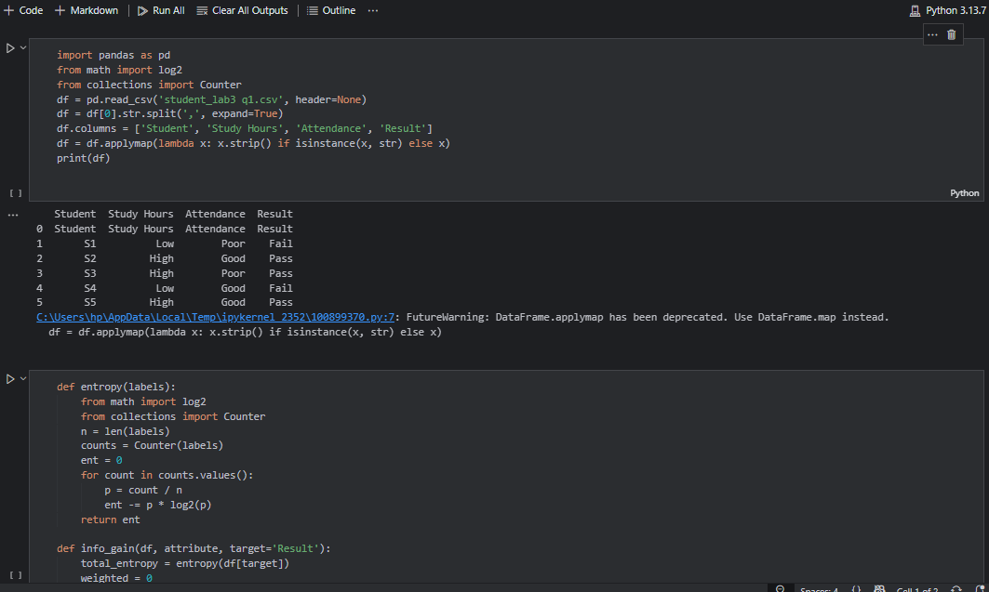
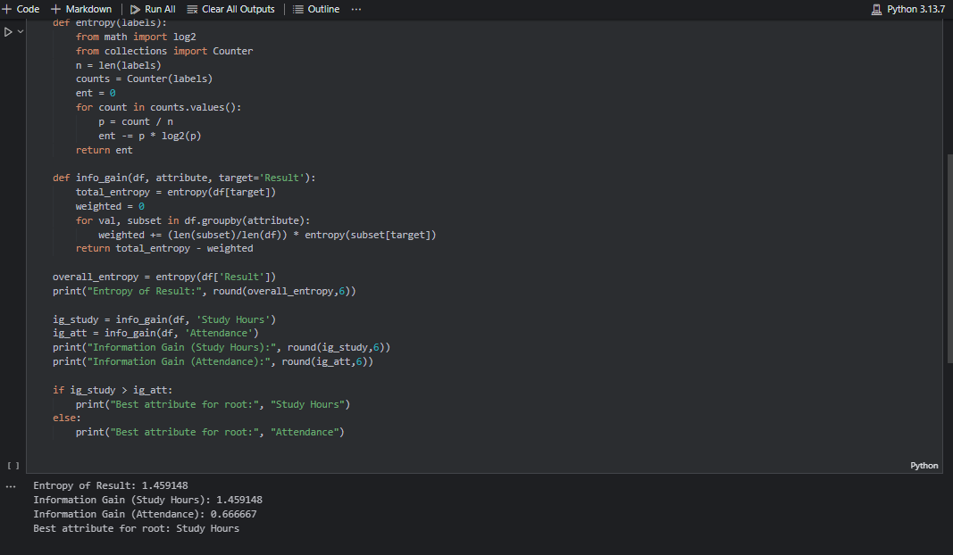
Question No. 2
Implement Decision Tree Classifier on a Small Dataset
Build and visualize a simple decision tree.
Question:
Using the same dataset as above:
- Use pandas to create a DataFrame.
- Convert categorical values into numerical using LabelEncoder.
- Train a DecisionTreeClassifier using criterion='entropy'.
- Visualize the decision tree using plot_tree() from sklearn.tree.
- Predict whether a student with Study Hours=Low and Attendance=Good will pass or fail.
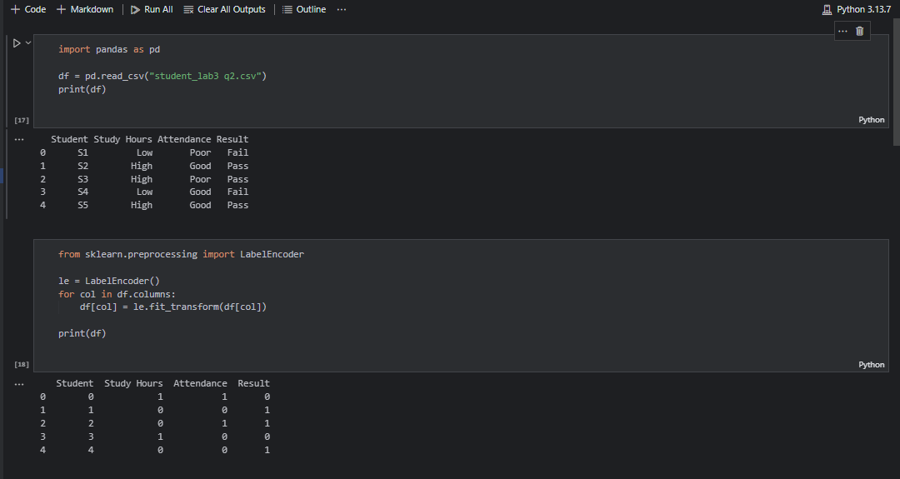
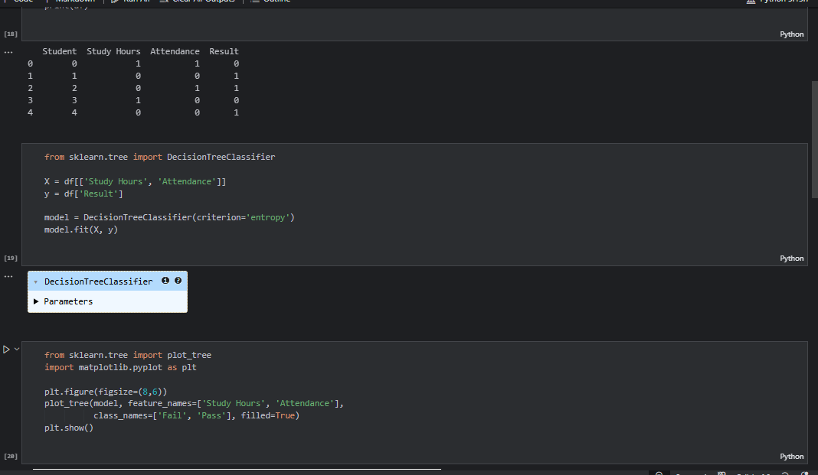
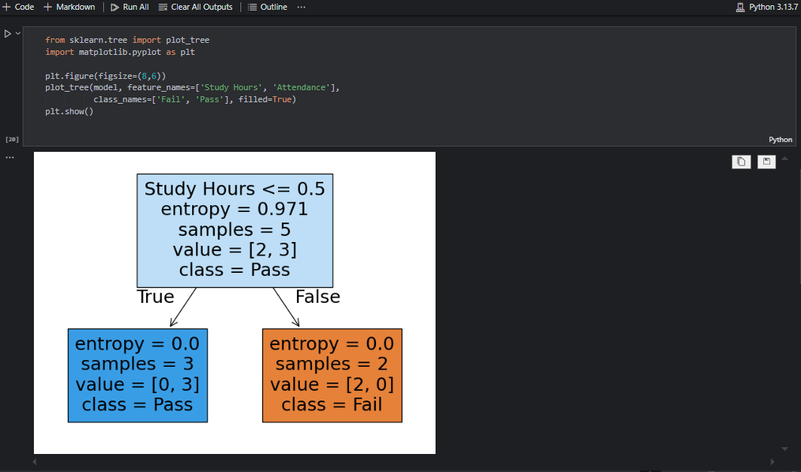
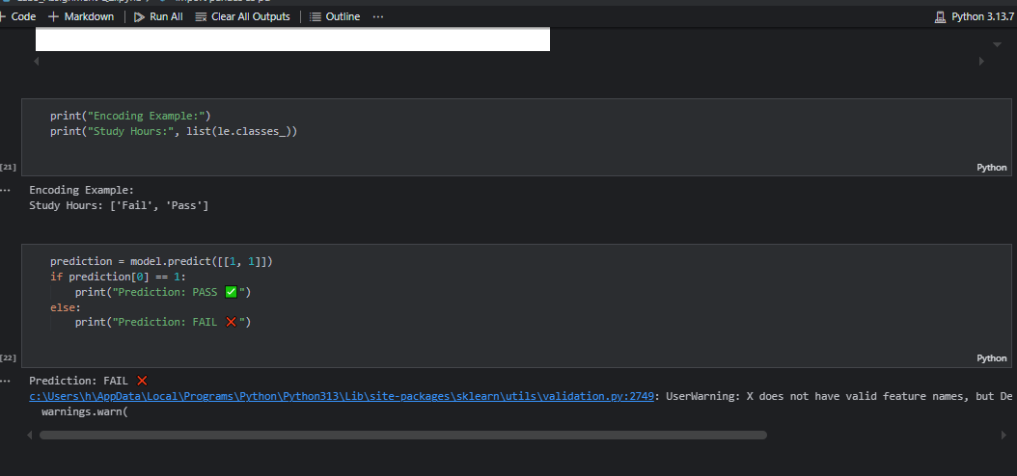
Question 3
Decision Tree Classifier on Iris Dataset
Objective: Apply decision trees to a real dataset.
Question:
- Load the Iris dataset using sklearn.datasets.load_iris.
- Split it into training (70%) and testing (30%) sets.
- Train a decision tree using criterion='entropy'.
- Print the accuracy on the test set.
- Visualize the tree and explain which feature provides the most information gain at the root.
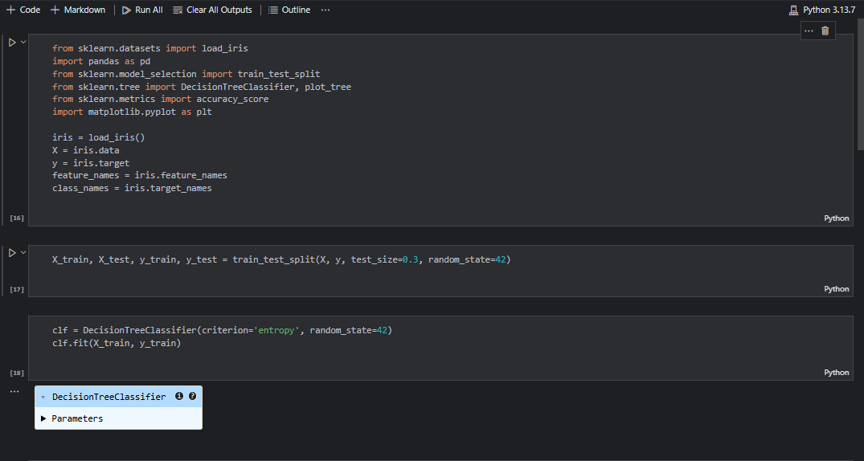
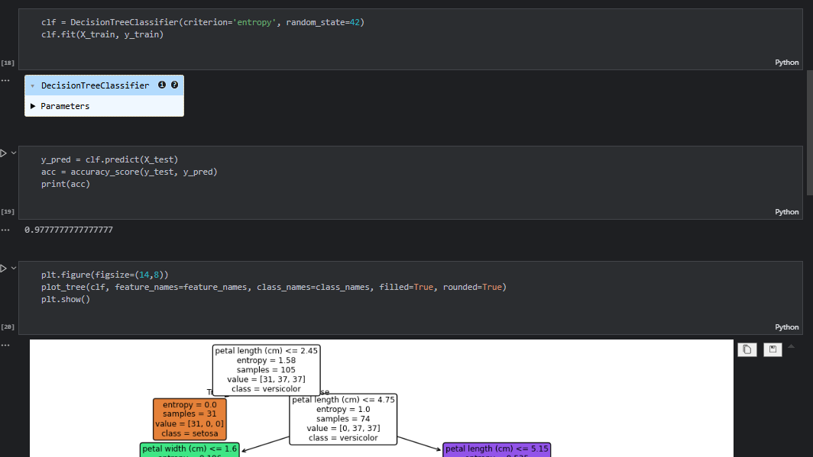
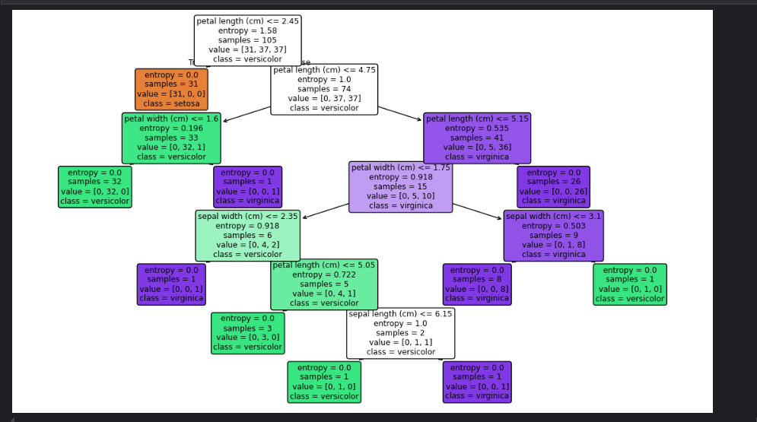
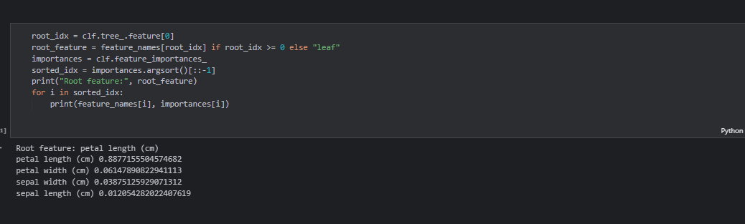

Question 4
MNIST digit dataset (available via Keras / sklearn.datasets) as a baseline
Objectives
- Preprocess image data for classification
- Train a Decision Tree Classifier (or variants)
- Evaluate accuracy, confusion matrix, and discuss limitations
